User Manual

User Module

Adding a query

A user can select a course using the provided combo box circled below.

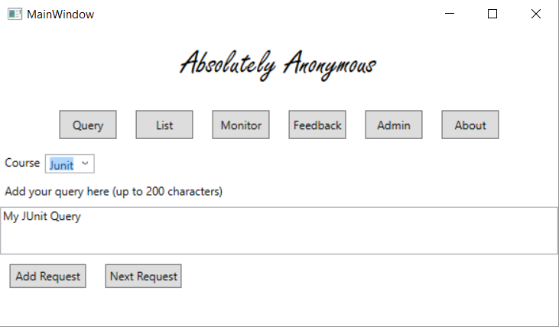

Add your query into the text space provided.



Click the “Add Request” button which fires the query into the List.



If you desire, there is a Next Request button which clears both the combo box and the query text space. Clicking this button will set you up for a completely new query that can be entered.

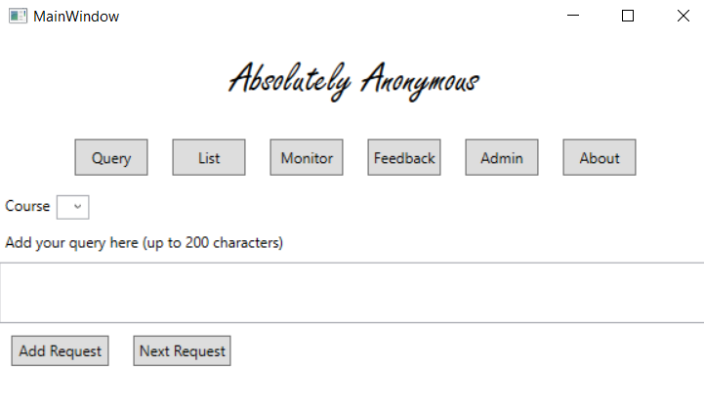

A user can navigate between tabs by clicking on the buttons below the title. As shown below. In this case, the user is able to view the list of queries which other users have made anonymously. This will include a query the user has just entered if they wanted to check whether their query has been added.

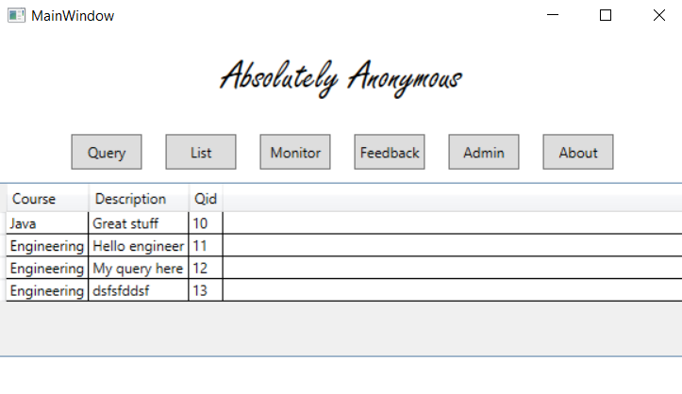

A user is able to view the about page upon selecting the “About” option.

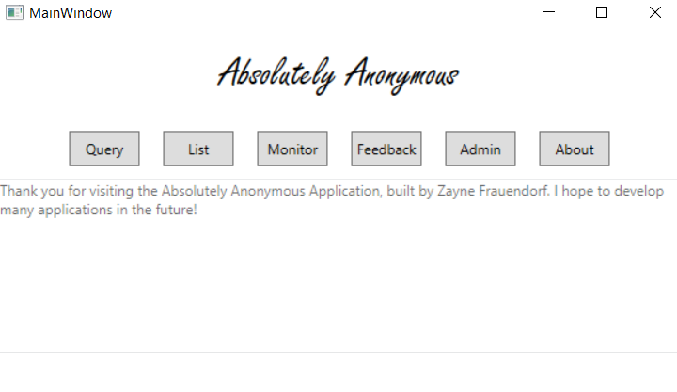

Admin Module

A user can access the “Monitor” tab by selecting the Monitor button.

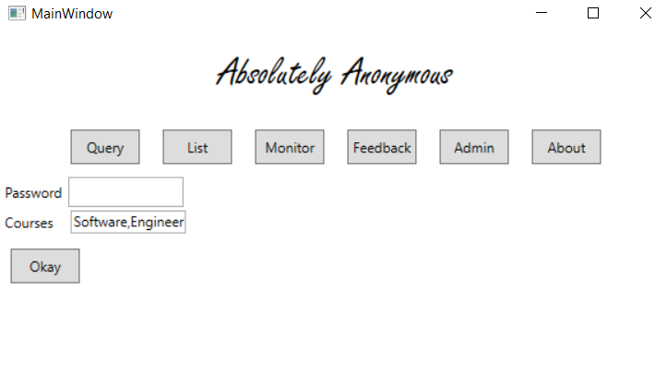

An admin can enter their password and then select the course(s) which they want filtered in the “Feedback” list. Each selected course must be separated by a comma. If successful the system will provide a notification which states the amount of courses being tracked.

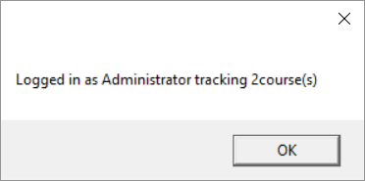

Once you’ve provided the password and received the above notification that you were successful you will be able to access the “Feedback” tab which will be populated with queries from courses which you’ve specified via the filter in the second textbox on the Monitor screen.

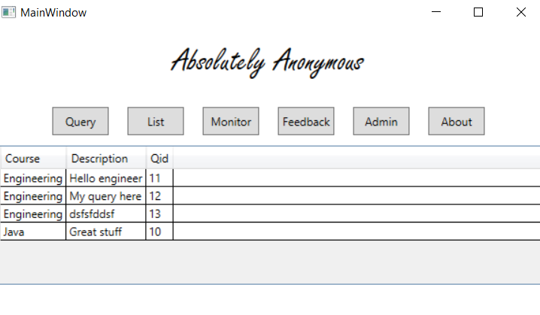

An admin is able to delete a query by selecting on of the rows in the data grid as shown below.



Once the admin selects, a notification will appear which asks whether or not the user is sure about deleting the query.

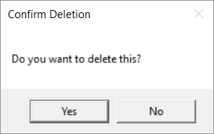

If the admin selects Yes, the query will be deleted instantly, otherwise if No then the admin will just return to the previous screen.

An admin can navigate to the “Admin” page by selecting the “Admin” button.

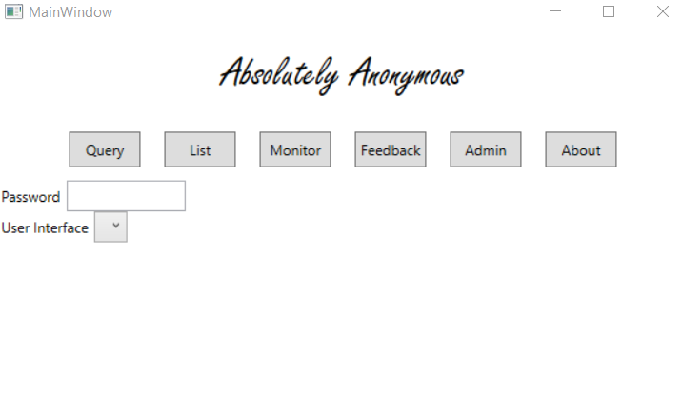

The admin must enter their password into the password box before clicking on the combo box. Upon entering their password the combo box will become available for use.

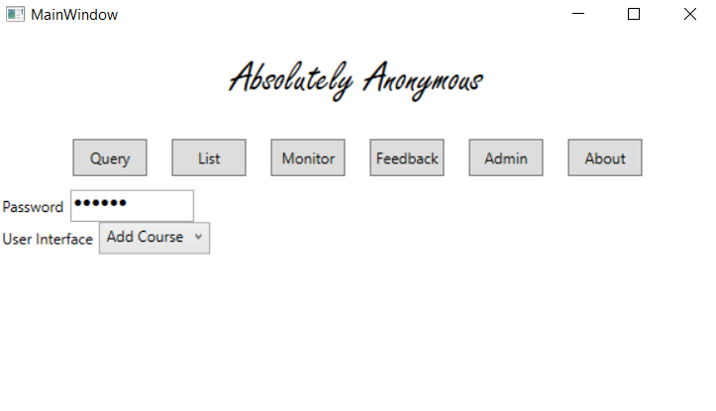

Once the correct password is in the textbox provided and the user selects “Add Course” or “Add User”, a new window will appear which looks like one of the below. The user can then fill out the details and click “Add” which will add that course or user to the current list.

